Student Name: Xianglong Lin Student Number: 45791439 Team Name: H2OMG
Week: _1_
Title: Wallet Design
Description:
In the 1st week, our team was assigned to participate in a design session. The team we formed began brainstorming and designing an ideal wallet. The original intention of the activity was to exercise our design thinking and teamwork skills and spirit. The activity content involved designing 5 different wallet designs, interviewing team members to understand their experience with current wallets on the market, providing feedback and reflection on the design sketches, and comprehensively improving the final wallet design scheme.
Visual Evidence:
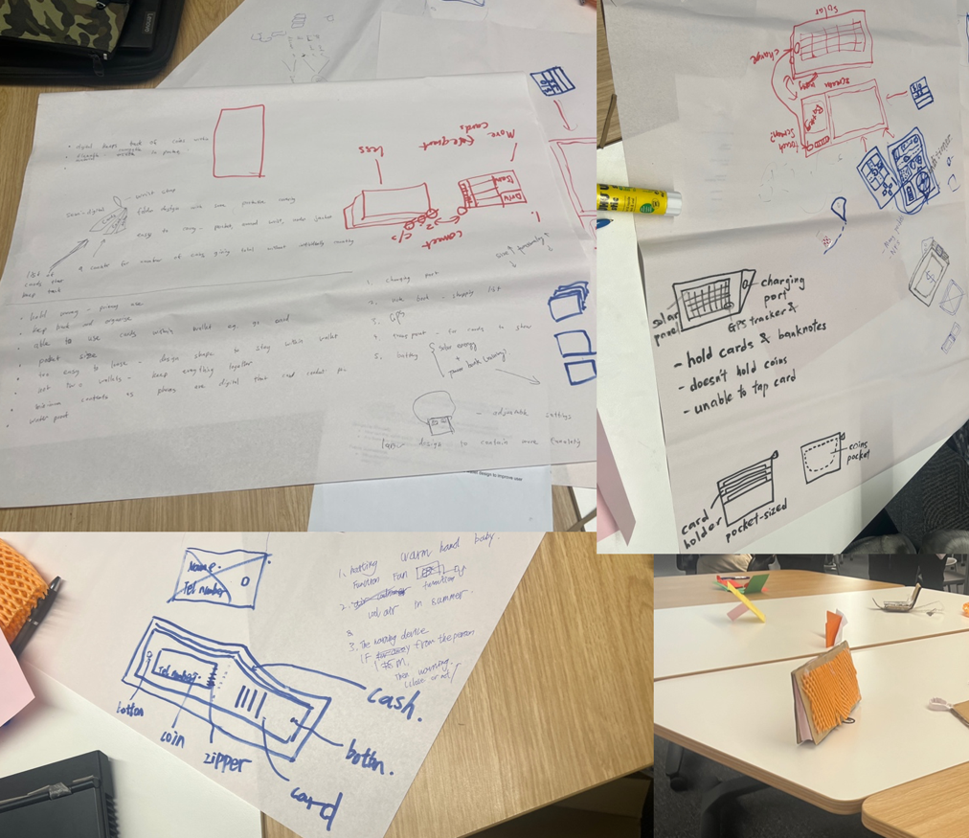
Statement on Learning:
This week's activities repeatedly emphasised the importance and necessity of empathy in design. The full implementation of research and interviews revealed the main pain points of users, such as the common problem of difficult placement of cards and the need for advanced features such as chargers. The design of multiple sketches actively promoted us to seek different solutions and find a balance between functionality and aesthetics. The feedback stage improved our team's understanding of user preferences. My experience and conclusion is that the function of a wallet is directly proportional to its size, and an increase in function is likely to lead to an increase in size, and vice versa. I was impressed by the wallet designs of the team members and other students, such as those that can print money, those that are folding, and those that use interlocking designs to expand functional areas. On the balance, this week's learning and practice opened my eyes to the depth of interactive design, and also made me realise the importance of teamwork communication and user feedback in design. Next, I plan to apply the knowledge and insights I gained from this week's studio experience to our upcoming projects and start building a team, striving to integrate and apply knowledge in a flexible and comprehensive way.

